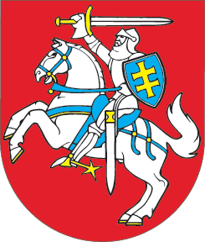

seimas of the republic of lithuania

resolution
amending resolution no XI-2133
of the seimas of the republic of lithuania of 26 june 2012
approving the nATIONAL ENERGY INDEPENDENCE STRATEGY

21 June 2018 No XIII-1288
Vilnius

The Seimas of the Republic of Lithuania resolves:

Article 1.
Resolution No XI-2133 of the Seimas of the Republic of Lithuania of 26 June 2012 Approving the National Energy Independence Strategy shall be amended and set forth to read as follows:

SEIMAS OF THE REPUBLIC OF LITHUANIA

RESOLUTION
APPROVING THE NATIONAL ENERGY INDEPENDENCE STRATEGY

The Seimas of the Republic of Lithuania, acting pursuant to Article 14(2) of the Law of the Republic of Lithuania on Energy, resolves:

Article 1.
To approve the National Energy Independence Strategy (appended).

APPROVED
by Resolution No XI-2133
of the Seimas of the Republic of Lithuania of 26 June 2012
(version of Resolution No XIII-1288
of the Seimas of the Republic of Lithuania of 21 June 2018)

NATIONAL ENERGY INDEPENDENCE STRATEGY

EXECUTIVE SUMMARY

ENERGY FOR COMPETITIVE LITHUANIA

- The objective of Lithuania’s energy sector is to meet the needs of the state of Lithuania, its citizens, and businesses. The National Energy Independence Strategy (hereinafter referred to as the Strategy) establishes the vision of Lithuanian energy sector, its implementation principles, strategic directions, objectives and tasks. Their achievement and implementation will be detailed in the Strategy’s Action Plan. The Strategy is implemented in the following four strategic directions:
  - COMPETITIVENESS. Energy costs account for a significant share of industry costs and household budgets. The global trends, including energy decarbonisation, market integration, digitalisation, urbanisation, need for enhanced energy efficiency, and development of technologies for the production and distributed energy generation of renewable energy sources (hereinafter referred to as the RES), necessitate changes in the energy sector. Therefore, the state will drive the energy sector toward meeting these global trends and the energy interests of its citizens and businesses. Energy prices will form in an effective market, which will be common with the other Member States of the European Union (EU). The country’s energy infrastructure will be used effectively, ensuring that the share of the cost of the infrastructure in the final energy price does not exceed the average for the EU Member States, while tariff patterns provide conditions for industrial investments. To achieve this:
    - The country’s well-developed energy infrastructure, which is being expanded further on the basis of a cost-benefit analysis, will be effectively used to increase the competitiveness of the state.
    - Competitive measures to promote investments in the development of reliable local generation facilities will be created and applied.
    - An effective regional market for natural gas of the Baltic countries will be established.
    - Smart and remote accounting and control systems will be implemented to encourage new services and opportunities.
    - When appropriate technical and market organisation conditions are in place, both electricity producers using RES and electricity consumers who are demand side response service providers will be able to participate in ensuring energy system reliability and providing system services; meanwhile, the market-oriented support system will promote the efficient functioning of the market and technology development.
    - Successful outcomes:
      - Final electricity and natural gas prices in Lithuania: for industry – the lowest in the region (compared to other Baltic, Scandinavian and Central and Eastern European countries), for citizens – a decreasing share of energy expenditure compared to the average income;
      - Increased market liquidity, simplified conditions for launching an energy business or start using energy services;
      - As Lithuania switches to the production of energy from non-polluting sources (emitting little greenhouse gases (hereinafter referred to as GHG) and air pollutants), the principles of sustainable development (all methods designed to ensure development that satisfies well-being in the present without sacrificing such opportunities in the future) will be used as a guidance, while causing no adverse economic consequences for the state, industry, and households.
      - Equal conditions of competition for state-owned and private entities.
  - RELIABILITY. The security and competitiveness of state, economic growth, and the welfare of the country’s citizens depends on the reliable supply of energy. Lithuania is a part of the European north–south energy corridor being developed, which stretches from Finland to the Central European countries. The energy security is assured by the fact of being a part of the European Union’s energy infrastructure, markets and systems, the availability of the required electricity-generating sources and alternative sources of gas supply. The country’s energy reliability and security shall be ensured as follows:
    - By synchronizing Lithuania’s electricity system with the electricity system of the Continental Europe. It is a strategic priority of the country’s security, so the synchronisation of Lithuania’s electricity system with the electricity system of the Continental Europe shall be implemented by 2025. Prior to the completion of the synchronisation with the electricity system of the Continental Europe, adequate high-availability generating capacities will be ensured in the most cost effective and non-discriminatory way.
    - By the completion of the Gas Interconnection Poland–Lithuania (GIPL), which will connect the Baltic states and Finland with the common gas market of the EU, improve supply security and diversification in the region, increase regional market liquidity and competition among suppliers, and allow for more effective use of the liquefied natural gas (LNG) terminal in Klaipėda.
    - The development of a safe infrastructure of Lithuania’s energy sector will strengthen the cyber resilience capabilities of the energy sector, will create the culture of cyber security, and will promote cooperation between the private and public sectors as well as international cooperation.
    - The outcomes of the improvement of the country’s energy reliability and security shall be as follows:
      - The Lithuanian electricity system will reliably operate in a synchronised mode with the electricity system of the Continental Europe.
      - Electricity imports will be replaced by local electricity generation: it is planned that in 2020 electricity generation in Lithuania will account for 35% of total final electricity consumption (65% imported), in 2030 – 70% (30% imported), and in 2050 – 100%;
      - Following a cost-benefit assessment, capacity development technologies and solutions will be selected that will provide the necessary reservation and balancing services through market mechanisms;
      - The natural gas transmission system will be connected to the EU gas transmission system via Poland, while the Klaipeda LNG terminal will meet the regional LNG needs;
      - The risk assessment based approach towards the assurance of cyber security will prevail in the energy sector, and cyber security will meet the organisational and technical requirements set by the Government of the Republic of Lithuania.
  - MITIGATION OF ENVIRONMENTAL IMPACT (energy savings and green energy). Efficiency of energy consumption improves the financial status of the country’s population, strengthens business competitiveness, and reduces environmental pollution. The aim is to increase energy efficiency and RES use as part of the daily life of each consumer, business or industry that purchases electricity, gas, biofuels or other fuels/raw materials. RES provide the most promising source of energy for the development of domestic production. Therefore, further development of RES and improvement of energy efficiency in line with reduction of environmental pollution will be supported by financial and non-financial measures:
    - In the long term, sustainable development of an energy sector free of GHG and air pollutants will be carried out, taking into account the growing need for resilience to natural phenomena caused by climate change;
    - RES will be used for the production of energy and biofuels;
    - Renewable energy will be developed by actively and consistently increasing the number of prosumers producing energy with the use of ambient technologies and by engaging local energy communities in RES development;
    - In ensuring the expansion of the use of solar energy, solar collectors will be implemented in the sector of district heat production;
    - The state will promote the integrated renovation of multi-apartment and public buildings (prioritising renovation in quarters);
    - Low-energy-intensive industries and industries increasing energy efficiency will be promoted, all industries will be encouraged to implement the latest environmentally friendly technologies and equipment.
    - Successful outcomes:
      - As technologies develop, the share of RES energy will be increasing due to more participants in the market. In 2020, 30% of the country’s total final electricity consumption will be from RES; in 2030 – 45%, and in 2050 – 80%. RES will become the main source of energy in electricity, heating and cooling, and transport sectors.
      - In 2030, the intensity of primary and final energy will be 1.5 times lower than in 2017 and in 2050 – 2.4 lower than in 2017;
      - By 2020, the renovated multi-apartment and public buildings will save around 2.6–3 TWh of energy and by 2030 – 5–6 TWh;
      - 1 TWh of electricity will have been saved across the country’s industries by 2030;
      - The amount of greenhouse gas emissions produced by fixed installations which participate in the EU Emission Trading Scheme will reduce by at least 43% by 2030 compared to the 2005 level;
      - The amount of greenhouse gas emissions produced by the sectors which do not participate in the EU Emission Trading Scheme (energy and industrial fuel firing installations of smaller than 20 MW capacity in the transport sector) will reduce at least by 9% by 2030 compared to the 2005 level;
      - The amount of greenhouse gas emissions produced by the energy and transport sectors will reduce by more than 95% by the year 2050 compared to the 1990 level.
  - PARTICIPATION OF THE COUNTRY’S BUSINESSES IN PURSUANCE OF ENERGY PROGRESS. From a country importing energy technologies, Lithuania needs to become a country creating and exporting energy technologies. Energy efficiency improvements by implementing building renovation programmes and ameliorating the efficiency of industrial enterprises’ production, also RES development create a large market for such services and an opportunity to expand employment opportunities and to develop innovative zero GHG and zero pollutant technologies and human resources’ skills. The country’s business development will be supported by the following measures:
    - By promoting the experimental and industrial development of the most promising energy technologies and innovation incubators, green, distributed energy generation, and digital solutions in the field of energy research;
    - By promoting information technology (IT) solutions for energy sector optimisation to be tested in Lithuania and exported;
    - Through cooperation between the LNG terminal, businesses, organisations and the country’s high and higher schools (including research institutes and universities), expanding the potential of the gas infrastructure of regional significance, LNG technologies, distribution, and excellence centre.
    - The outcome of the implementation of changes in the energy sector and capacity building:
      - The establishment of well-paid jobs and increase of high value-added exports of energy technologies and knowledge;
      - Lithuania is a centre of information technology and cyber security solutions for energy, biomass and biofuel technology, solar and wind energy technology, geothermal technology, energy market development, improvement of electricity system operation, development of new electricity system management methods and implementation of energy projects.
- The strategic directions of the Lithuanian energy sector, which shall enjoy increased attention during certain periods, will be followed in implementing the outlined objectives and tasks:
2020  ENERGY-SECURE STATE |  | 2030  COMPETITIVE ENERGY |  | 2050  ENERGETICALLY SUSTAINABLE AND INDEPENDENT STATE
Objectives  - Integration of the energy system in the EU energy system  - Improvement of energy efficiency of energy consumption  - Balanced and sustainable RES development  - Optimisation and modernisation of energy infrastructure |  | Objectives  - Energy price in the industry sector will be the lowest in the region (compared to other (Baltic, Scandinavian and Central and Eastern European countries); for citizens – a decreasing share of energy expenditure compared to average income  - Smooth transition from fossil-based energy sources to RES |  | Objectives  - 80% of the country’s energy needs is generated from non-polluting (zero emissions of GHG and air pollutants) sources  - 100% of local electricity production in the country’s gross electricity consumption
Tasks  - Synchronisation of the Lithuanian energy system with the energy system of the continental Europe  - Improvements of energy efficiency of energy consumption (targets established by the EU are implemented)  - RES development – focus on development of prosumers and biomass and wind energy, use of RES for the production of district heating and household heating  - Construction of interconnections (GIPL) and decision on the long-term LNG imports to Lithuania  - Ensuring balanced local capacities in production, reservation and balancing; following a cost-benefit analysis, the development of Kruonis Pumped Storage Power Plant |  | Tasks  - Improvements of energy efficiency of energy consumption (energy intensity will not exceed the EU average)  - RES development – focus on development of prosumers and wind energy as well as further use of RES for the production of district heating by installing effective biomass cogeneration plants and for household heating  - Use of alternative fuels in the transport sector and its electrification  - Establishment of necessary conditions for the development of non-polluting energy production methods. Development of small and flexible local energy generation units |  | Tasks  - Completion of necessary conditions for the development of non-polluting energy production methods  - Development of effective and non-polluting energy production, supply, storage/accumulation, and consumption technologies

Fig. 1. The results sought in the Lithuanian energy sector for the years 2020, 2030 and 2050 (in accordance with the strategic directions of increased attention of the Lithuanian energy sector outlined in the previous table of item No. 2)

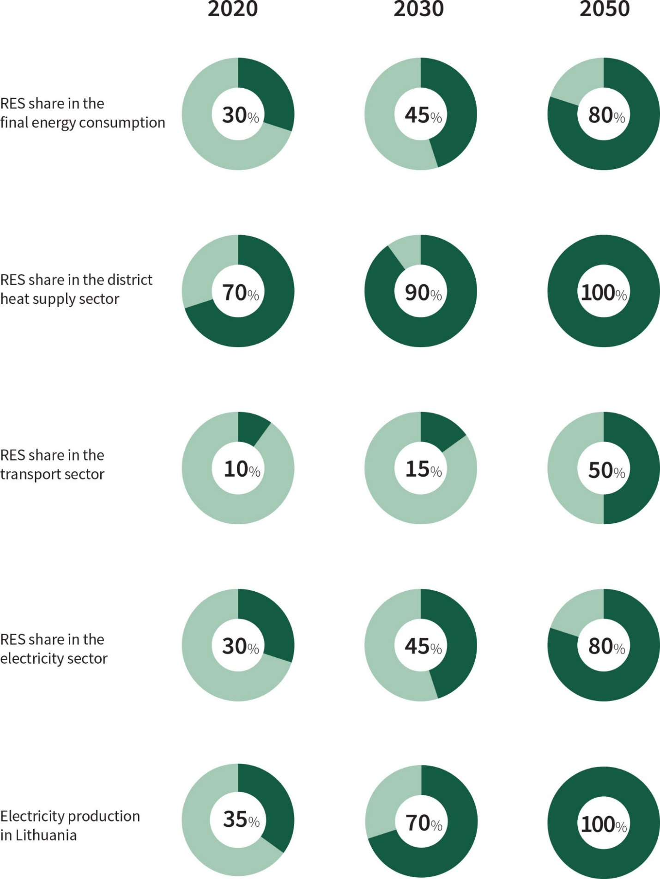

ENERGY RESOURCE CONSUMPTION TRENDS

Fig. 2. Total consumption of fuel and energy in Lithuania in 2016, %
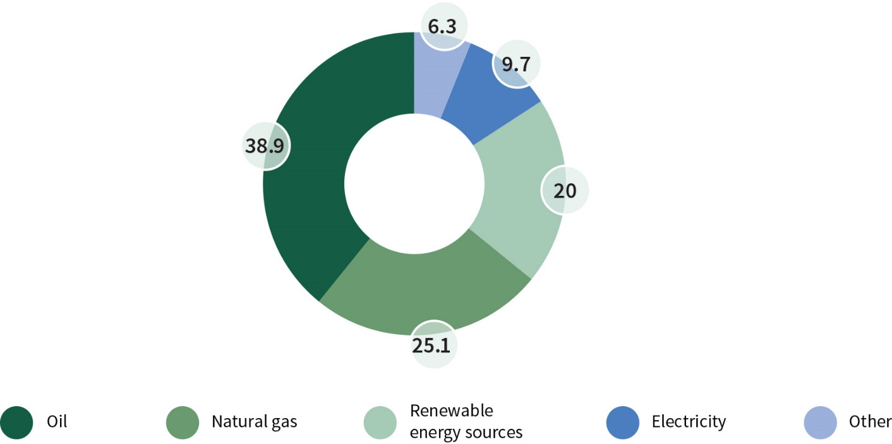
Source: Lithuanian Department of Statistics.

Fig.3. Dynamics of consumption of primary energy sources up to 2050, GWh
(excluding the need for gas as a raw material in the production of fertilisers and consumption of petroleum products for non-energy purposes)
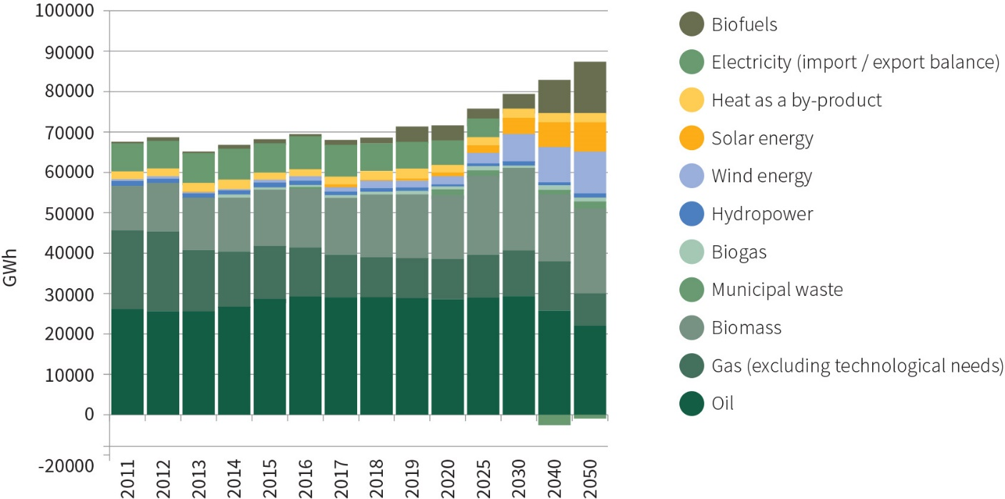
Source: Lithuanian Energy Institute

Fig. 4. Foretasted final energy demand according to fuel and energy types up to 2050 in ktoe
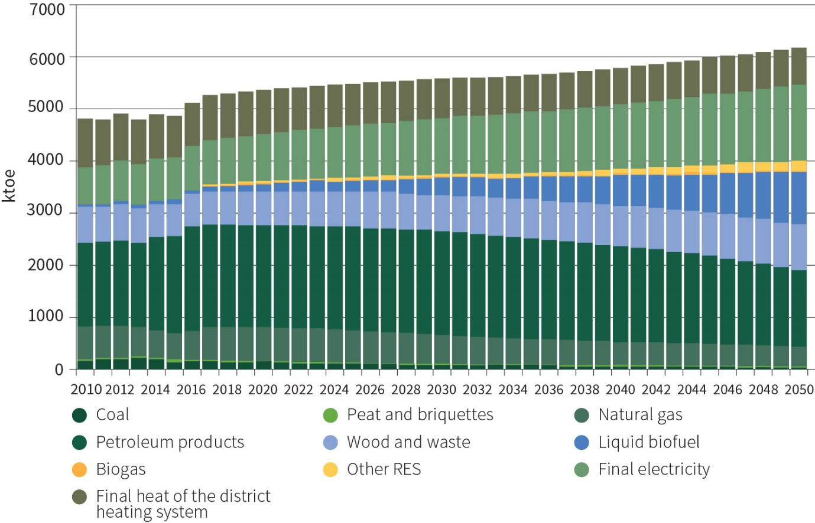
Source: Lithuanian Energy Institute

Fig. 5. Energy consumption and GDP growth forecasts up to 2050
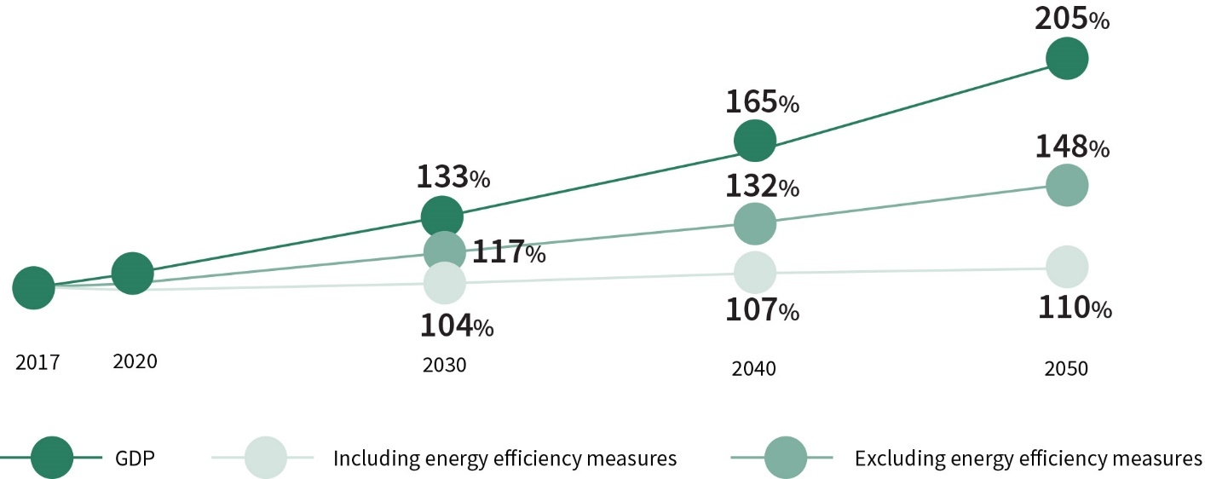
Source: Lithuanian Energy Institute, Ministry of Energy of the Republic of Lithuania.

Fig. 6. The dynamics of carbon dioxide emissions resulting from fuel combustion up to 2050
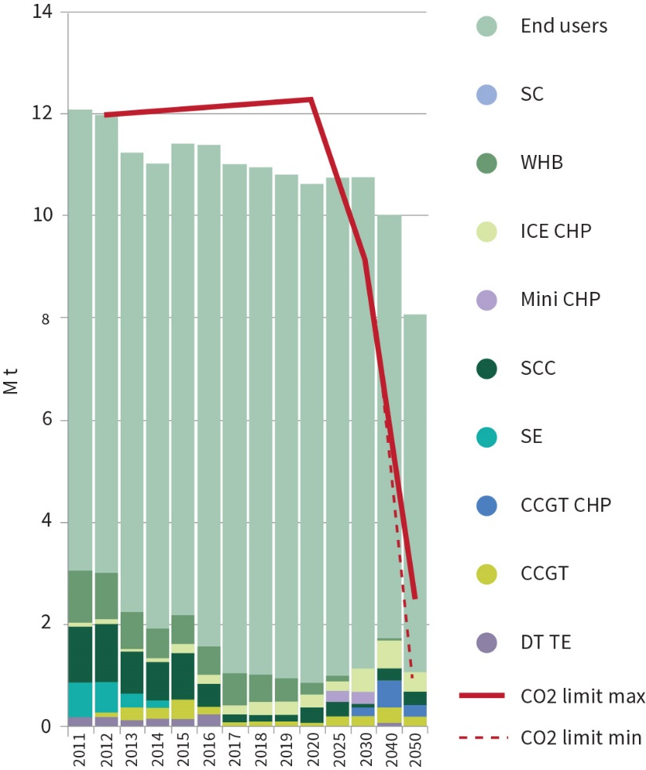
Source: Lithuanian Energy Institute

CHAPTER I

INTRODUCTION

- The structural reforms and strategic projects of the energy sector, carried out in Lithuania as a result of implementing the National Energy Independence Strategy approved by Resolution No. XI-2133 of the Seimas of the Republic of Lithuania dated 26 June 2012, have diversified energy supply routes and sources, reduced energy resources prices for consumers, and opened new development opportunities for the country. The Lithuanian energy sector has been substantially restructured in order to reduce and eventually eliminate the energy dependence on the Russian Federation that has resulted in unreasonably high resource prices and the use of energy as a political tool.
- With regard to these results of the implementation of the National Energy Independence Strategy and the new EU energy and climate change targets that Lithuania has to achieve by 2030 by implementing the Paris Agreement of 12 December 2015 between the EU and the United Nations (UN) (hereinafter referred to as the Paris Agreement), and the new trends in the energy market and also targets of the EU Energy Union and the Baltic Energy Market Interconnection Plan, this updated Strategy has been prepared, which includes state’s key energy policy targets, directions and their implementing tasks up to 2030 and a vision up to 2050. The strategic goal of the state in the energy field is synchronisation of the Lithuanian energy system with the energy system of continental Europe. This goal has to be reached by 2025.
- In the future, the continuity of the pursued policy and directions will be maintained, the investment attractiveness of Lithuania will be improved, new zero GHG and zero pollutant technologies resilient to climate change will be implemented, innovations in the energy sector will be encouraged, and energy progress will be ensured.

CHAPTER II

LITHUANIA’S ENERGY POLICY IN THE EUROPEAN UNION

- The EU’s energy sector is facing significant challenges: heavy dependence on energy imports and the issue of energy supply security, the reduction of GHG emissions in pursuit of long-term climate change mitigation targets under the Paris Agreement, and the remaining prevalent use of fossil fuels in the energy mix compared to all other energy resources used.
- In response to these challenges, the EU’s energy and climate change policy, which is based on the principles of greater integration, security of energy supply, competitiveness, and sustainable development, is consolidated and consistently reinforced. In implementing the EU’s climate change and energy policy objectives up to 2030, approved by the European Council in 2014, and the EU’s Energy Security Strategy (hereinafter referred to as the European Energy Security Strategy), the EU’s Energy Union concept was initiated in 2015, setting out the assurance of energy supply security and solidarity between the Member States, the establishment of a fully integrated European energy market, the improvement of energy efficiency, and the reduction of the dependence of the economy on fossil fuels by linking energy and climate change policies.
- The obligations of the EU Member States agreed upon in the context of the EU’s energy policy will be mostly achieved, and part of them will be surpassed by 2020. Therefore, even more ambitious targets of the EU’s energy policy have been agreed upon for 2030: to reduce greenhouse gas emissions by at least 40% (compared to the level of 1990), to increase the share of RES in energy consumption and energy efficiency at the EU level by at least 27% (to increase the energy efficiency target to 30% in 2020, if possible). Also, to achieve at least 15% connectivity of the EU Member States by electricity interconnections, taking into account the regional and national specifics of the EU Member States. It is estimated that successful continued implementation of these energy and climate change policies would allow the EU to reduce GHG emissions by 80–95% by 2050 (compared to the level of 1990).
- The implementation of the EU energy policy objectives for 2030 and the concept of the Energy Union is to be ensured through a common European Energy Governance System, based on the drawing up of National Integrated Energy and Climate Action Plans, which in the future, in Lithuania, could replace strategic planning documents related to the Strategy insofar as it does not conflict with strategic interests and national safety.
- The vision of the updated Strategy and the main strategic objectives, directions, and tasks of the development of the country’s energy sectors are substantially in line with the EU’s energy and climate change policy and the objectives of the Energy Union.
- Lithuania’s interests in respect of the objectives of the EU’s energy policy are as follows:
  - Completion of the EU’s internal energy market. After having been isolated from the EU’s internal energy market and networks for a long time, Lithuania supports the EU’s infrastructural, regulatory, and financial measures aimed at further integration into the EU’s internal energy market, while taking advantage of the benefits it offers in respect to increased energy security, competitiveness, and sustainable development. A fully integrated and effectively functioning internal energy market of the EU is a priority objective of Lithuania.
  - Assurance of energy security in the Baltic region. The aim will be to implement, as quickly and fully as possible, the provisions of the European Energy Security Strategy and to ensure that the results of the implementation of the measures of this Strategy are regularly reviewed at the EU level.
  - Implementation of the targets of the EU’s climate change and energy policy. The balanced development of EU’s renewable energy sources and energy efficiency improvement will be encouraged. Obligations related to the development of local and renewable energy sources and energy efficiency improvement after 2020 shall be based on the burden sharing principle, which ensures the respective contribution of each EU Member State in the pursuance of the objectives relating to renewable energy sources and energy efficiency improvement on the EU level by 2030.
  - Adequate EU’s long-term financing programming policy. The aim will be to ensure the continuity of the financial instruments of the EU for energy infrastructure and decommissioning of the Ignalina Nuclear Power Plant and adequate funding in order to alleviate the financial burden on Lithuanian consumers
  - Strengthening of the EU’s external energy policy. The strengthening of the EU’s external energy policy, coordinated actions of the EU Member States and their solidarity in cases of crises also enhance Lithuania’s security. Therefore, reinforced EU’s dialogue with the key energy resource suppliers, especially with the US, Canada, Norway, and Australia will also be pursued.

CHAPTER III

STRENGTHS, WEAKNESSES, OPPORTUNITIES AND THREATS (SWOT) ANALYSIS OF THE LITHUANIAN ENERGY SECTOR

- Strengths:
  - Abolished energy isolation from the EU’s internal energy market and enhanced energy security through interconnections with Scandinavian and Polish electricity networks and implementation of a real gas security alternative – the LNG terminal in Klaipėda.
  - Developed gas and electricity transmission infrastructure and diversified supplies of energy sources.
  - Acquired excellence in the fields of electricity interconnections and LNG infrastructure development and LNG trade, and management of nuclear power plant decommissioning projects.
  - High-capacity terminals for oil and petroleum product import and export and a steadily operated oil refinery.
  - Operation of well-developed district heating supply (DHS) systems in all cities.
  - Faster-than-EU-average development of RES over the past 12 years, coupled with the relatively low commitments to investors in the development of energy-generating capacities that use RES, the development of the biomass industry, and the acquisition of excellence in the conversion of biomass to energy and solar energy technology production.
  - A positive attitude of the public towards the use of RES, the growing number of companies preparing for the use of RES energy in their activities, and favourable conditions for the development of RES.
  - Achieved financial stability of the energy sector (capable of overcoming shocks and the effects of financial imbalances).
  - The creation of a system for modernising/renovating public and multi-apartment buildings, increasing energy efficiency, gradually transitioning to renovation in quarters.
- Weaknesses:
  - Heavy dependence on the import of energy sources and leaps in prices of imported energy sources.
  - Non-competitive and insufficient local generation of electricity, physical and technological obsolescence of a large part of electricity and some heat production facilities. Insufficient competition in electricity reserve and balancing markets.
  - Heavy dependence on the import of energy production, supply and storage technologies.
  - Relatively high costs of the maintenance of the natural gas and electricity supply/transmission infrastructure.
  - Complex and excessive regulation of the heat sector. Insufficiently attractive connection to DHS systems.
  - More than 70% of multi-apartment residential buildings and a large portion of public buildings are energy-inefficient, and their slow modernisation can cause severe economic and social consequences.
  - Growing GHG emissions in sectors not participating in the EU’s Emissions Trading System (ETS), and CO2 emissions in the transport and agricultural sectors.
  - High pollutant emissions from household heating equipment due to the use of biofuels and other solid fuels and inefficient heat production equipment.
  - Insufficiently consistent regulatory and investment environment that does not create a level playing field between the public and private sectors.
- Opportunities:
  - The use of natural gas and electricity infrastructure on regional level and establishment of Lithuania as a regional energy centre.
  - LNG supply infrastructure and reinforced main gas networks as well as a new gas pipeline to connect Lithuania with Poland, reinforcement of the interconnection between Lithuania and Latvia and, in cooperation with other Baltic countries and Finland, the on-going development of the necessary regulatory and market organisational principles that will allow the functioning of the regional natural gas market of the Baltic countries and Finland.
  - Sale of energy products, technologies and excellence created in Lithuania, thus strengthening the economy and international prestige of the state.
  - Great potential for improving the efficiency of energy production and consumption, with simultaneous reasonable growth of final energy needs and rapid growth of electricity needs.
  - Use of funds of public service obligations, allocated on an annual basis for the production of electricity from RES and its balancing, reducing the current level and acting on the basis of the best European practices.
  - By rationally using local and/or renewable energy sources in DHS systems, it is possible to further reduce the need for the imports of primary energy sources.
  - Rehabilitation of inefficient household/housing heating facilities and other heat generating facilities with the help of EU support.
  - Reinforcement of the competitiveness of the industry by optimising the energy tariff policy in accordance with the best European practices.
  - The electrification of transport, which will considerably reduce GHG and air pollutant emissions and need for imported fossil fuels, and improve the use of existing infrastructure.
- Threats:
  - Dependence of the electricity network on the Russia-controlled energy systems of the Commonwealth of Independent States’ (IPS/UPS) synchronous zone. The electricity system of Belarus, Russia, Estonia, Lithuania and Latvia (BRELL), which applies market organisation, balancing, and other rules different from those applied by the EU, is developed without the involvement of Lithuania and the country is unable to have any impact on the system.
  - Expansion of unsafe nuclear power plants in the region, which poses threats to national security and the energy system
  - In the years to come, thanks to the capacity of the inter-system electricity interconnections, Lithuania will be able to cover all of its electricity needs from imports from EU Member States; however, excessively large dependence on electricity imports would affect the country’s energy security.
  - Decreasing consumption of natural gas and heat energy, which will cause increasing energy infrastructure maintenance costs per energy unit.
  - The growing number of cyber incidents in the energy system, which poses threat to the stable operation of the country’s energy system and its security.

CHAPTER IV

VISION OF THE LITHUANIAN ENERGY SECTOR

- The vision of the Lithuanian energy sector is the advanced energy industry that uses zero GHG and non-polluting energy sources, creates added value to the state and the consumer, is resilient to cyber threats and climate changes, and ensures reliable supply of energy at a competitive price. Pursuant to 2030 UN Agenda for Sustainable Development, the objectives of the Paris Agreement, EU’s 2030 climate change and energy targets, in 2050 the Lithuanian energy sector will produce 80% of energy from non-polluting sources (zero emissions of GHG and air pollutants), will supply energy to consumers safely and at a competitive price, and will contribute to the country’s modern economy, its competitiveness and attraction of investments. Energy production sources will include renewable energy sources and technologies capable of producing energy without polluting the environment. Consumers will be enabled to produce energy required to cover their needs. The implementation of the vision of the Lithuanian energy sector by 2020 is estimated to require up to 2.4 billion euros, and in 2021–2030 – up to 10 billion euros in public, including the EU, and private funds for the development and modernisation of the energy sector and the restoration of worn out facilities.
- The vision of the Lithuanian energy sector is based on the Paris Agreement adopted under the UN Framework Convention on Climate Change, the strategic provisions for EU’s 2030 energy and climate change policy targets, and the energy legislation of the EU and the Energy Union.
- The mandatory joint target for the EU (reducing GHG emissions by at least 40% by 2030, as compared to 1990) defined in the EU’s 2030 Climate and Energy Framework is aligned with the EU’s target to reduce GHG emissions by 80–95% by 2050.
- The general principles of the implementation of the vision of the Lithuanian energy sector:
  - To reduce energy dependence on import, while promoting the use of local sources and RES and implementing energy efficiency improvement measures, installing zero GHG and zero air pollutant technologies;
  - To ensure the uninterrupted energy supply from secure, reliable sources functioning in accordance with market rules, to reduce the dependence of national energy systems on dominating energy suppliers, while providing conditions for the diversification of energy sources and competition;
  - To carry out the comprehensive integration of national energy systems in the EU energy market and systems and the common European internal energy market;
  - To ambitiously fight climate change and air pollution by installing zero GHG and zero air pollutant technologies, as RES and energy efficiency improvement targets should contribute to the EU’s climate change and energy targets, while the solutions should ensure their implementation;
  - To ensure current or increased reliability: in parallel to RES development, the electricity system balancing, reservation and other system network services should be ensured in the most efficient way, and the RES energy producers themselves should be involved in their provision;
  - In implementing the 2050 vision and selecting measures, to be guided by economic rationality, environmental impact, and social responsibility;
  - New energy projects shall only be launched after a cost-benefit analysis;
  - To implement innovations: the development of Lithuanian energy sector should be based on smart technologies and digitalisation of the energy industry;
  - To create technologies: from a country importing energy technologies, Lithuania needs to become a country exporting high-added-value technologies for the energy sector;
  - To develop, broaden, and use the acquired energy excellence, knowledge and created infrastructure by expanding the partnership between the public and the private sectors and ensuring the attraction of investments for sustainable development of the energy sector;
  - To ensure fair competition between public and private businesses and a level playing field for all actors in the energy sector;
  - To attract investments for the creation and development of energy technologies;
  - To ensure cyber security of the energy sector’s infrastructure.

CHAPTER V

KEY AREAS, STRATEGIC OBJECTIVES, TASKS AND OUTCOMES OF LITHUANIAN ENERGY SECTOR

SECTION I

RENEWABLE ENERGY SOURCES

- In 2016, RES accounted for about 25.5% of final energy consumption in Lithuania. Accordingly, consumption of electricity from RES was about 17%, in total heat consumption – about 46%, and in the transport sector – about 4%. A significant share of resources in energy production comes from wind and biofuels (solid and liquid).
- The main objective of the Strategy in the field of RES is to continue to increase the share of RES in domestic energy production and total final energy consumption, thus reducing the dependence on fossil fuel imports and increasing local electricity-generating capacities.
- Although RES technologies are constantly improving and the cost of equipment decreases, RES-generated energy produced in newly-installed plants is currently not yet able to compete in the market. Therefore, the production of RES energy is and will continue to be supported until the economically and technically acceptable RES development limit is reached, focusing on the proactive participation of RES energy producers under market conditions, or until the production of RES energy reaches market value.
- The development of RES in Lithuania must be carried out in accordance with the following principles:
  - Gradual integration of RES in the market – the most cost-effective technologies shall be developed, technological maturity shall be considered, taking into account its development trends in the near future;
  - Affordability and transparency – the RES incentive scheme must be market-based, minimise market distortion and ensure minimum financial burden on energy consumers, clarity and a non-discriminatory competitive environment;
  - Proactive participation of energy users – as the share of RES in the energy consumption increases, decentralised electricity production must be encouraged, consumers must be allowed to use RES energy for their own needs and to receive a reward for surplus energy supplied to the network in line with the market conditions, and consumer behaviour and energy demand and supply management solutions must be introduced.
- In pursuit of the strategic RES target, the aim will be to increase the share of RES in the total final energy consumption of the country to:
  - 30% by 2020;
  - 45% by 2030;
  - 80% by 2050. RES will become the main source of energy in electricity, heating and cooling, and transport sectors.
- The main directions for achieving the target:
  - To increase the share of electricity consumption from RES up to 30% in 2020, 45% in 2030 and 80% in 2050 compared to the final electricity consumption:
    - By 2020, the share of RES in final electricity consumption will grow to 30% and will constitute no less than 3TWh. From the perspective of technology development trends, it is estimated that electricity produced from wind will become the main source of RES energy and by 2020 might reach up to 44%, biomass – up to 26%, hydropower – up to 19%, energy produced in solar power plants – up to 6%, and biogas – up to 5% of all RES-generated electricity consumed.
    - A lot of attention will be paid to the production of decentralised electricity from RES. The number of electricity consumers who can generate electricity for their own needs will be gradually increased. By 2020, after creating a favourable investment environment, there will be at least 34 thousand electricity consumers using a prosumer scheme.
    - Energy production from wind energy in the Baltic sea after 2020 is to be conducted taking into consideration the following:
25.1.3.1. research carried out and other actions taken which are required for the adoption of decisions regarding territories which are appropriate for organisation of contests and for identification of the installed capacity of power plants;
25.1.3.2. assurance of the adequacy of capacities of the Lithuanian energy system given the synchronisation of the Lithuanian energy system with the European energy system;
25.1.3.3. results of the cost-benefit analysis.
    - By 2025, at least 38% of electricity consumed in Lithuania will be produced from RES and will constituted no less than 5 TWh. Taking into consideration the assessment of the technology development trends, it is estimated that at least 50% of RES-generated electricity could come from wind, 20% from solar, 15% from biofuel, 12% from hydropower, and about 3% from biogas.
    - By 2030, no less than 45% of electrical power consumed in Lithuania will be produced from RES and will constitute no less than 7 TWh. With technology development trends in mind, it is estimated that the majority of electricity – no less than 53% – could come from wind power, 22% – from solar energy, 16% – from biofuel energy produced in highly efficient co-generation power plants, and 8% – from hydropower. Biogas could generate about 1% of electrical power.
    - By 2050, electricity generated from RES will constitute no less than 100% of power consumed in Lithuania, and the amount of energy produced from RES will be no less than 18 TWh.
    - The vital prerequisite for RES development is the assurance of the required adequacy of capacities of the Lithuanian energy system. Taking into consideration the required capacity, the state will ensure the availability of reservations and other system network services by creating an appropriate regulatory environment, while the responsibility for balancing will be borne by the RES-generated electricity producers in line with the EU guidelines. Regional and international cooperation will be gradually promoted in order to reduce the costs of developing RES.

Fig. 7. Market structure by the amount of RES-generated electricity consumed, % and GWh (forecast)
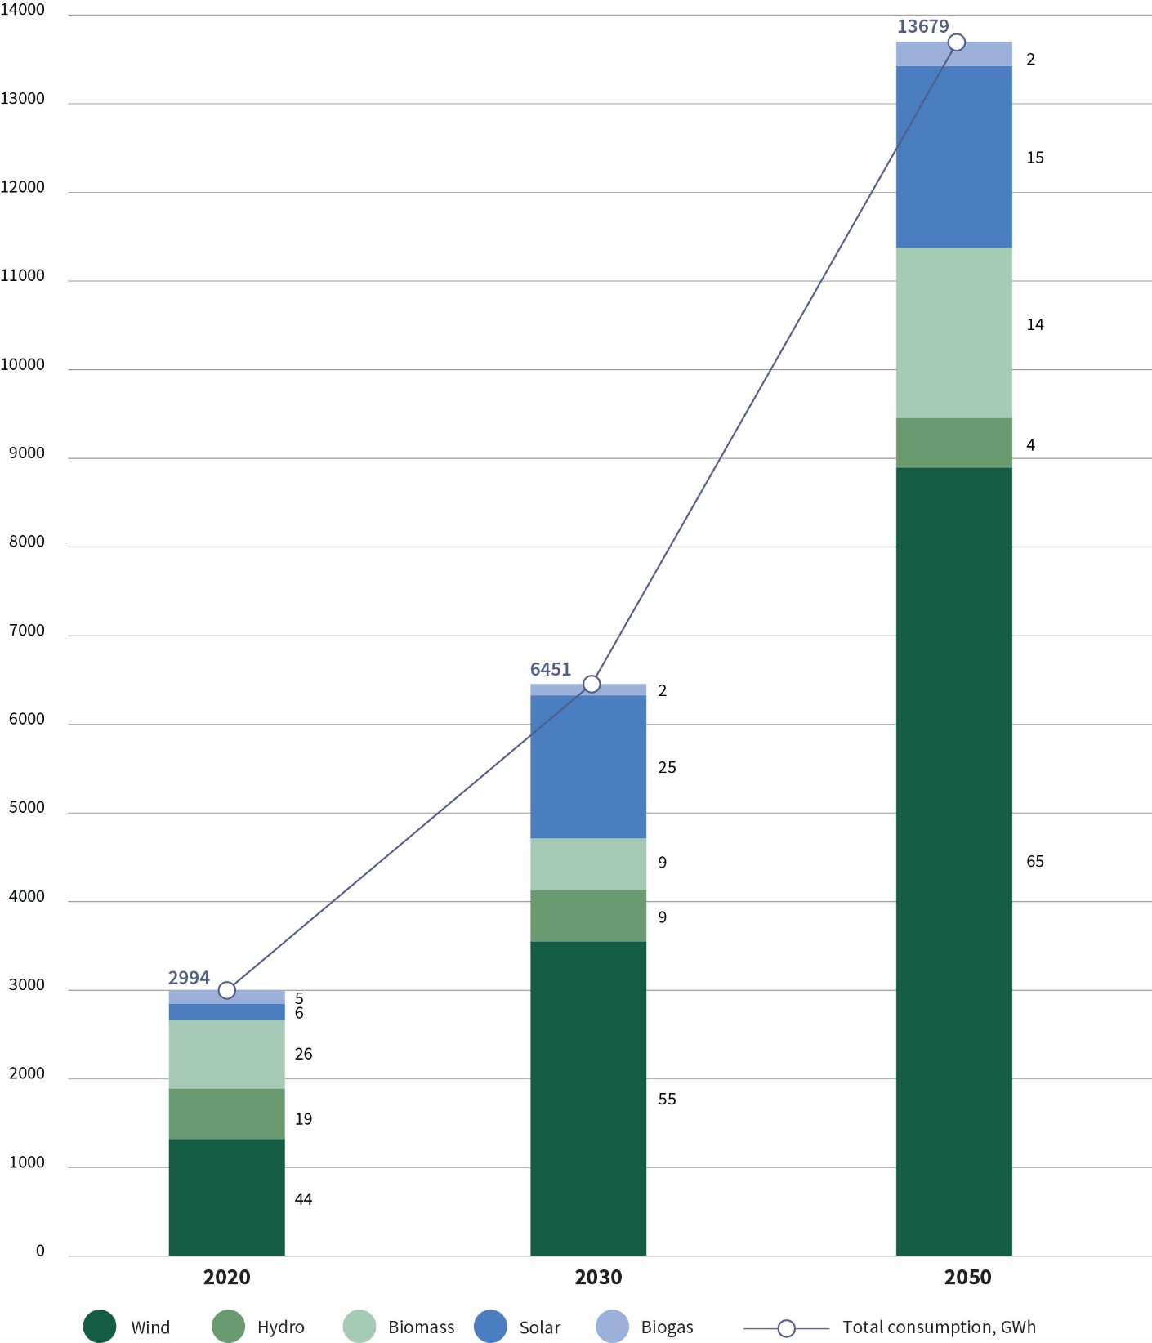
Source: Lithuanian Energy Institute, Ministry of Energy of the Republic of Lithuania.

    - In the long-term perspective, electricity consumers will become proactive participants in the market and will be given the opportunity to use energy generated from RES for their own needs to receive a reward for surplus energy supplied to the network in line with the market conditions. Such consumers will account for at least 30% of all consumers by 2030 and at least 50% by 2050. These customers will be able to participate in the market through service providers in the energy sector. The active participation of local energy communities in investing in co-owned RES equipment will be encouraged.

Fig. 8. The share of prosumers compared to all consumers, %
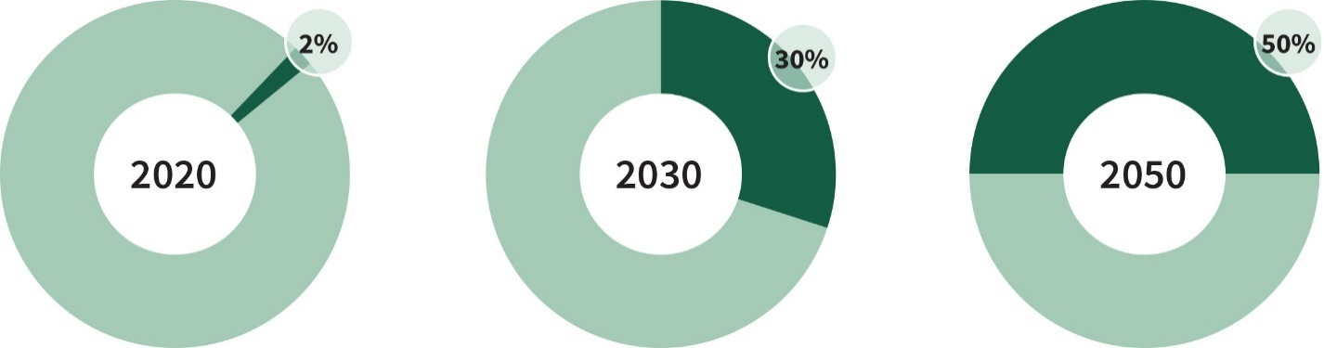
Source: The Ministry of Energy of the Republic of Lithuania.

  - To maximise the share of RES for district heat consumers, households with individual heating and non-household consumers with individual heating:
    - Up until 2020, RES consumption will continue to increase as compared to district heat consumption and in individual heating in households.
    - The share of DHS RES will be 70% by 2020 and 90% by 2030. The development of high-efficiency solid biomass CHP plants will continue, non-recyclable municipal waste non-hazardous industrial waste that have energy value will be effectively used for energy production.
    - After creating a favourable regulatory environment, households with independent heating will gradually switch to clean, zero GHG technologies and the share of RES in households will reach 70% by 2020 and 80% by 2030. GHG producing technologies will be replaced by clean, clean-air technologies that do not impair the quality of air.

SECTION II

ENERGY EFFICIENCY IMPROVEMENT

- Energy efficiency improvement is one of the most important objectives in the EU and Lithuania. Energy efficiency is usually evaluated by the primary and final energy intensity, which indicates how much energy costs went into the production of a specific amount of goods and services in the country (the ratio of country’s energy consumption to its GDP). In 2010-2015, the energy intensity of the country’s economy consistently decreased (primary energy – 32%, final energy – 31%), and in 2015 was the smallest among the three Baltic States at 205 kgoe/1000 EUR (in Latvia – 207 kgoe/1000 EUR, Estonia – 358 kgoe/1000 EUR). Lithuania is still behind (by about 70%) the EU average (120 kgoe/1000 EUR).

Fig. 9. Energy intensity in EU Member States, kgoe/1000 EUR
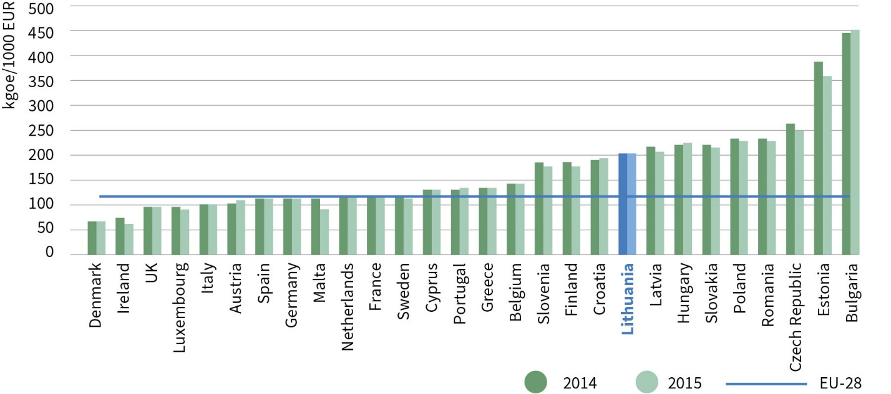
Source: Eurostat.

- The greatest potential for energy efficiency improvements based on the economic feasibility of effectiveness measures is in the industrial, building and transport sectors.
- In the industrial sector, energy costs in total product cost remains high and is on average 20% higher than the EU average; therefore, more efficient and modern technologies and also energy management measures are needed to reduce energy costs and increase the competitiveness of enterprises.
- Multi-apartment residential buildings consume the most amount of heat energy in Lithuania, i.e. 54% of final heat energy consumption. It is in this area, which accounts for 60% of all buildings by area, that the largest potential for saving energy is observed.
- In 2010-2015, final energy consumption in the transport sector increased by 18%, while the sector itself consumes about 38% of the total final energy. It is therefore necessary to increase energy efficiency in this sector and to implement energy efficiency measures related to it.
- The main objective of the Strategy in improving energy efficiency is to ensure that the intensity of primary and final energy by 2030 is 1.5 times lower than in 2018, and by 2050 it is about 2.4 times lower than in 2018.

Fig. 10. Energy intensity reduction forecasts up to 2050
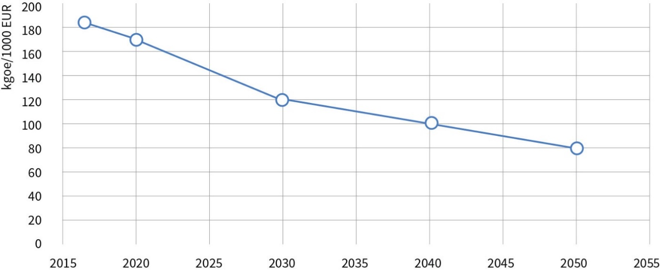
Source: Lithuanian Energy Institute, Ministry of Energy of the Republic of Lithuania.

- Energy efficiency improvement in Lithuania will continue to be carried out in accordance with the following principles:
  - Economic feasibility – the most cost-effective energy efficiency improvement measures should be given priority when implementing energy efficiency improvement objectives;
  - Proactive training and education of energy consumers – since energy consumers can contribute to energy efficiency objectives by changing their behaviour and habits, energy consumer training and education must be strengthened;
  - Competition – by allowing investors in energy efficiency improvement to compete with each other for the most economically advantageous projects, by implementing energy efficiency improvement obligations or by competing for the state support.
- In pursuit of the energy efficiency improvement objective, the aim will be to:
  - ensure the implementation of the EU requirements for energy efficiency improvement in Lithuania by 2020 (i.e. total energy savings of 11.67 TWh) and the financing of compliance with these requirements;
  - by 2030, ensure that primary and final energy intensity is 1.5 times lower in 2030 than in 2018;
  - by 2050, ensure that primary and final energy intensity is about 2.4 times lower than in 2018.
- The main directions for achieving the target:
  - To promote integrated renovation of multi-apartment and public buildings (prioritising renovation in quarters) and to save about 2.6–3 TWh of energy in the renovated multi-apartment and public buildings by 2020 and 5–6 TWh by 2030 (by adding up savings in each year).
  - To promptly develop low-energy-intensive industries and industries increasing energy efficiency, the deploy and acquire the most up-to-date and environmentally-friendly technologies and equipment.
  - To increase energy efficiency in the transport sector by renovating the fleet, switching to modern and efficient public transport, optimising the infrastructure for the use of transport and alternative fuel by electrifying or using alternative fuels.

SECTION III

ELECTRICITY SECTOR

- In 2016, the total installed electricity-generating capacity in Lithuania was 3591 MW, 2222 MW out of it constituted the reliably available power for peak consumer demand of the requested capacity. In 2016, the peak demand was 1979 MW. The projected peak demand will be 1980 MW in 2020, 2450 MW in 2030, and 3150 MW in 2050. At the same time, however, the reliable power is expected to decrease down to 2261 MW in 2020, and 1599 MW in 2030 and 2050. Therefore, one of the challenges to be solved in the near future will be the management of the imbalance between the increasing peak demand and the decreasing reliable power after 2020. Energy interconnection capacities allowing to ensure the adequacy of the electricity market are increasing: in late 2015 – early 2016, after the Lithuania – Sweden (NordBalt) and Lithuania – Poland (LitPol Link) energy interconnections were launched, the total capacity (except capacity from third countries) increased to 2435 MW, and in 2030 it is expected to increase up to 2935 MW. Poland (LitPol Link) interconnections were launched, the total capacity (except capacity from third countries) increased to 2435 MW, and in 2030 it is expected to increase the capacity up to 2935 MW.

Fig. 11. Electricity-generating capacity in Lithuania and energy interconnection capacities (forecast)
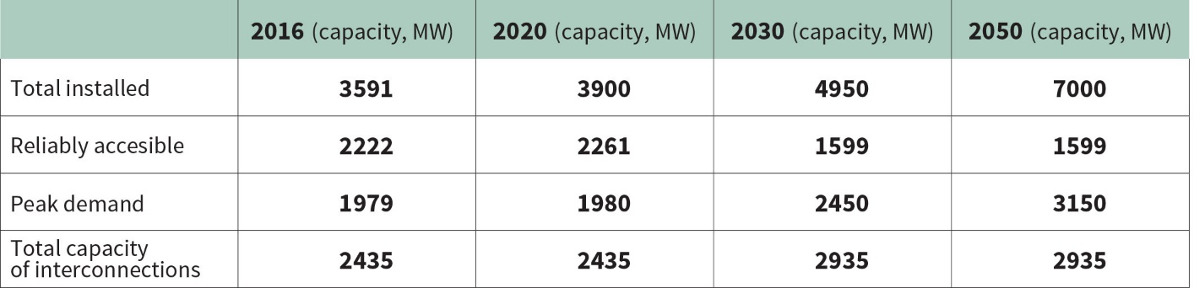
Source: Litgrid AB.

- In 2016, Lithuania produced a total of 3.97 TWh of electricity. Half of all electricity produced in the country was generated by power plants using renewable energy sources. About 0.45 TWh of electricity was generated by hydropower plants (excluding Kruonis PSPP), 1.13 TWh – by wind turbines, and about 0.44 TWh was produced by solar, biomass and biogas fired power plants. The remaining amount of electricity was produced by conventional fuel-fired power plants. The largest share of electricity consumed in the country (about 72% of total electricity consumption or 68% of total electricity demand) was imported in Lithuania during 2016. Most of it (37%) was imported from Latvia and Estonia, (27%) – via NordBalt interconnection with Sweden, (5%) – via LitPol Link interconnection with Poland, and the rest (31%) – from third countries.

Fig. 12. Lithuanian electricity balance in 2016
(total electricity demand in 2016 was 12.25 TWh)
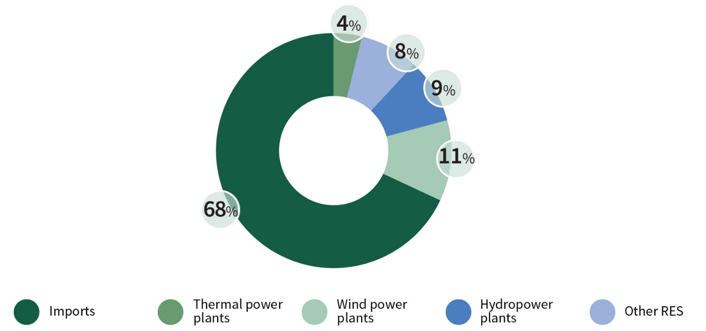
Source: LITGRID AB.

- In the first half of 2017, the electricity transmission system operators of Lithuania, Latvia and Estonia assessed the adequacy of the Baltic electricity system for the next 15 years, from 2017 to 2032. In the study, the operators evaluated all the information related to the installed capacities of new and planned to be closed generating units in the region, as well as their technical capabilities to provide system services. An assessment of reliable wind power was carried out in the Baltic region and the reliable power of hydropower and pumped storage plants was estimated. According to the available data, a total power of 272 MW worth of new reliable electricity generating facilities are planned for deployment within the Baltic electricity system by 2032. Meanwhile, the total power of plants scheduled for closure may reach 2315 MW.
- According to the study, as of 2025, if operation in isolated regime is necessary due to an emergency, the Baltic electricity system would lack 200 MW of initial reserves. Therefore, by the year 2025, new reliable power plants must be deployed in the Baltic states in order to ensure the seamless operation of the Baltic electricity system and reliable electricity supply when it starts operating in sync with continental European networks.
- The main electricity objectives of the Strategy when working in synch with the electricity system of the continental Europe and operating within the common EU electricity market:
  - To make flexible use of the opportunities offered by the power interconnections with the EU Member States;
  - To develop the electricity sector in a sustainable way by integrating it into the domestic EU market and ensuring reliable and competitive reservation and balancing capacities and increasing domestic electricity-generating capacities from non-polluting sources or using renewable energy sources that would meet the energy demand of a self-sufficient state;
  - To ensure that the interests of the electricity consumers in the country are met by improving the services essential to consumers and aiming to achieve that electricity prices were the lowest in the region in the industrial sector (among the Baltic, Scandinavian and Central and Eastern European countries), and for citizens – a decreased share of energy expenditure compared to the average income.
- The objectives of the electricity sector must be pursued in accordance with the following basic principles:
  - Energy independence – the energy dependence on electricity imports must be reduced while maintaining local reliable and competitive energy production and ensuring sustainable development of the electricity sector by increasing domestic electricity-generating capacities that would meet the country’s electricity needs and be in line with the balance of economic, social, climate change and environmental requirements;
  - Sustainable integration and security – the integration of Lithuanian electricity system into European electricity systems must be continued in order to contribute to the establishment of the Energy Union and the common EU electricity market by making flexible use of the opportunities offered by these integration processes for a reliable supply of electricity to consumers in the country;
  - Increasing competitiveness – the functioning and long-term development of the electricity sector must be based on solutions that increase the competitiveness of the Lithuanian economy sectors both within the region and at the EU level;
  - Innovation development – the development of the Lithuanian electricity sector must be based on the deployment of smart electricity technologies, such as smart power energy networks and smart electricity accounting systems, as well as other innovative technologies;
  - Proper information and involvement of consumers – when promoting decentralised electricity production, it must be ensured that consumers are informed in a due and timely manner, and electricity management measures must be implemented with the aim to engage consumers in network management and electricity markets.
- In pursuit of the strategic objective of the electricity sector, the electricity needs of the domestic consumers will be satisfied by using energy generation technologies that are competitive on the electricity market, and for the purposes of ensuring energy security, priority will be given to RES technologies and other technologies that have zero GHG and air pollutant emissions. Thus, the aim will be to achieve that:
  - by 2020, 35% of the total final energy consumption of the country consists of local electricity generation;
  - by 2030, 70% of the total final energy consumption of the country consists of local electricity generation;
  - by 2050, 100% of the total final energy consumption of the country consists of local electricity generation, marking the start of RES-generated electricity as the main source of electricity, as compared to the total final electricity consumption of the country.

Fig. 13. Electricity production in Lithuania after considering long-term electricity objectives
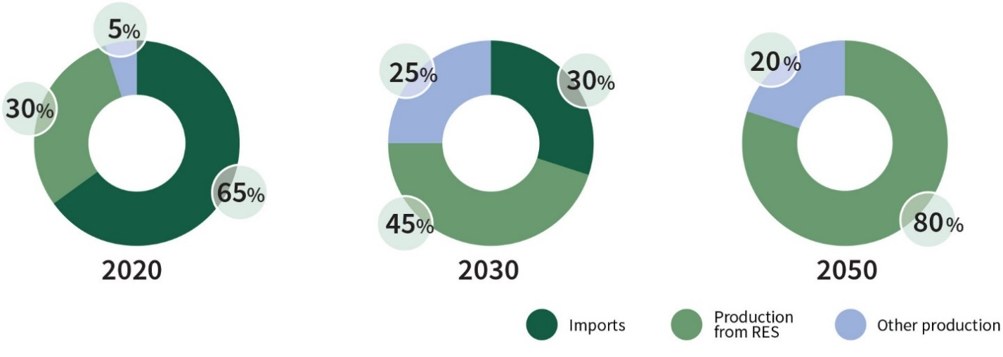
Source: The Ministry of Energy of the Republic of Lithuania.

- Main directions and tasks for achieving the electricity objectives:
  - Synchronisation of Lithuania’s electricity system with the European electricity system:
    - To implement the project that involves connecting the electricity system of the Republic of Lithuania to that of the continental European for synchronous operation via the electricity system of the Republic of Poland. The disconnection of the Lithuanian electricity system from synchronous work with IPS/UPS and synchronisation with the electricity system of the continental Europe is necessary in order to ensure and maintain energy security. This project must be implemented by 2025.
    - In order to properly prepare for the implementation of the project of synchronising the electricity system of the Republic of Lithuania with the electricity system of the continental Europe, to participate in the isolated work test of the electrical systems in Lithuania, Latvia and Estonia, which must happen by 2019. During the test, the electricity transmission system operator of the Republic of Lithuania must take all possible measures to ensure the reliability and stability of the system, while the users of the electricity system shall carry out the prescribed test conditions in a responsible manner;
    - All the necessary technical and organisational measures for the timely preparation of the Lithuanian electricity system infrastructure for its connection to the electricity system of the continental Europe for synchronous operation must be implemented without delay:
42.1.3.1. the project of optimisation of electrical power transmission network of Northeast Lithuania must be implemented;
42.1.3.2. by 2020, the second link of power transmission line Lithuania’s power plant–Vilnius must be installed;
42.1.3.3. a new power transmission line Kruonis–Alytus must be built;
42.1.3.4. reorganisation of power transmission lines with the third countries must be implemented in Lithuania so as to ensure synchronous operation with the European energy system.
42.1.4. All necessary technical and organisation measures, which ensure the potential of synchronous operation of the Lithuanian energy system with the energy system of continental Europe, must be put into effect in the period from 2021 to the final and complete synchronisation with the energy system of the continental Europe in the mode required for the assurance of reliability.
42.1.5. Following the connection of the electricity system of the Republic of Lithuania to that of the continental Europe for synchronous operation (by 2025), there cannot remain any opportunities for electricity from third countries to directly enter the Lithuanian electricity market or electricity could enter the Lithuanian electricity system solely to such extent to which this could be required, should any inevitable technical reasons necessary for de-synchronisation from the energy system of the Commonwealth of Independent States (IPS/UPS), including the Kaliningrad Oblast, be discovered.
  - Ensuring a smart electricity market:
    - To ensure the integration of the Lithuanian electricity market into the common European electricity market and increase the liquidity of the electricity market by applying common European electricity market rules and advanced electricity market solutions.
    - To gradually abandon the regulation of retail electricity prices. To achieve that the regulation of retail electricity prices by applying social tariffs in line with certain requirements will only be possible in exceptional cases, thus protecting socially vulnerable electricity consumers and not increasing energy poverty in the country.
    - To ensure the application of equal competitive conditions and responsibilities in the electricity market for all electricity generation technologies as well as balanced operation of the electricity system.
    - In view of the RES growth, to ensure the flexibility of the short-term electricity market; to create preconditions for advanced demand side response solutions, where consumers can proactively engage in the electricity market either directly or through energy service providers and sell the electricity necessary for the balancing of the electricity system by deciding to adjust consumption in the short term.
    - To seek to create a competitive and user-oriented electricity market environment.
    - To completely separate the electricity supply, electricity distribution and transmission markets.
    - In order to ensure the competitiveness of the Lithuanian industrial sector within the region, to ensure optimum electricity pricing as well as to improve the reliability of electricity supply to industrial customers in defined industrial zones.
  - Lithuanian electricity generation:
    - Taking into account the results of the Lithuanian generation capacity assessment, electricity market mechanisms must be immediately developed and applied to promote balanced investment in the development of reliable local generation and/or maintenance of current generation.
    - To prioritise electricity generation in power plants where electricity is generated by using a high-efficiency cogeneration method.
    - As the importance of generating decentralised electricity from RES grows, it is necessary to keep increasing the number of electricity consumers who can produce electricity for their own needs. In the long run, electricity consumers will become proactive participants in the market and will be given the opportunity to use energy generated from RES for their own needs to receive a reward for surplus energy supplied to the network in line with the market conditions. According to plans, the number of consumers who use power produced from RES for their own needs is expected to account for at least 30% of all consumers by 2030 and at least 50% by 2050. During these periods, such users would become a significant source of local power generation.
  - Ensuring the adequacy of Lithuanian capacities:
    - Before and after the implementation of the project of synchronisation with the electricity system of the continental Europe (including during the isolated work of the electrical systems of Lithuania, Latvia and Estonia), to ensure the reliable adequacy of the capacities of the Lithuanian electricity systems, taking into account the results of the joint assessment of the Baltic generation capacities carried out in 2017.
    - To establish appropriate technical, competitive and market conditions in order to satisfy the needs of system services by local power generation, including power plants using RES, and demand side response services provided by electricity consumers.
    - After carrying out a cost-benefit analysis before the end of 2018 and having a socio-economic justification, to initiate prior to the end of 2023 the following:
      - deploy additional flexible generation capacities not exceeding 200 MW in Lithuania and/or implement flexible demand management measures to ensure the adequacy of the electricity system;
      - implement the project of the fifth synchronous aggregate of Kruonis Pump Storage Power Plant in order to ensure the provision of reservation and balancing services.
    - To carry out an assessment of the need for an additional electricity link with Sweden (NordBalt II) and to decide on the implementation of the project, taking into account the need for implementation and the opportunities within the Baltic region.
  - Smart and sustainable development of the electricity system:
    - To deploy smart electricity accounting systems and smart grids as well as a data hub or other similar solutions based on best global practices at the same time ensuring cyber security of the systems and networks as well as energy data protection. Following a cost-benefit analysis of the deployment of smart electricity accounting systems and obtaining a positive result, smart electricity accounting systems must be deployed for all users by 2023.
    - In order to increase the reliability and resilience of the electricity distribution network to meteorological effects, the new electricity distribution network lines (if there is an economic justification) should only consist of cables. Worn out power lines of the electricity distribution network (0.4–10 kV overhead lines) should also be replaced, with priority given to the line age, accident-proneness and location in wooded and economically exploitable areas. With application of the latest smart energy network technology and rational replacement of terrestrial lines of power distribution network with cable power lines, to seek that by 2020 the reliability indicators of the operator of distribution network (namely, the system average interruption duration index (SAIDI), and system average interruption frequency index (SAIFI)) improved at least 25% (SAIDI – 100 min, SAIFI – once) (in comparison to SAIDI 138 min, SAIFI – 1.31 times in 2017), by 2030 – at least 50% (SAIDI – 70 min, SAIFI – 0.66 times) (compared to SAIDI – 138 min, SAIFI – 1.31 times in 2017), and by 2050 – the operator of distribution network was among the best EU operators of energy distribution network.
    - To ensure the quality and reliability of electricity supply to provide consumers with the right services.
    - To ensure that electricity consumers are informed properly and timely in order to involve them in the management of the electricity grid and to encourage them to become proactive players in the market.
  - The implementation of international and national objectives and tasks that affect the security of the electricity sector, the sustainable development of zero GHG emissions and competitiveness:
    - To ensure that the electricity market of the Republic of Lithuania is not directly exposed to electricity from third countries where unsafe nuclear power plants are used.
    - To seek to establish the principle of a level playing field at the EU level in trade with third countries, the main criteria of which should be the obligation to apply to third countries the same energy production requirements as are applied within the EU in terms of nuclear safety and environmental protection (including GHG emissions); also the obligation to ensure parallel market access conditions (reciprocity principle).
    - To ensure that EU and international organisations issue nuclear safety and environmental decisions and recommendations regarding the nuclear power plant under construction in the Ostrovets District in the Republic of Belarus, recognised as unsafe in 2017 and posing a threat to the national security of the Republic of Lithuania, its environment and public health, in line with the interests of Lithuania.

SECTION IV

HEATING AND COOLING SECTOR

- The country’s district heating system is an integral part of the overall energy sector, closely tied by technological and energy ties to the electricity system, fuel supply and other systems. Well-developed district heating systems are in place in all Lithuanian cities and supply about 53% of all buildings nationwide and about 76% of all buildings citywide. The main users of DHS are residents living in multi-apartment buildings. In 2016, 17,840 buildings (about 700 thousand apartments) with DHS supply of 27,359 total consisted of multi-apartment houses, where heat sales amounted to about 72.6% of the total amount of heat sold. The remaining users are budgetary institutions (14%) and business organisations (13.9%)
- As natural gas has been rapidly replaced by biofuels since 2011, the price of DHS has decreased, but the key issue, namely inefficient heat consumption, remains relevant. In 2016, a total of 8.9 TWh of heat energy was produced and supplied to the networks. It is estimated that as the number of district heating customers grows, accompanied by rapid investments in more efficient energy consumption, by 2020 district heating systems will supply 8.9 TWh, by 2030 – 8.5 TWh, and by 2050 – 8.0 TWh of heat energy. The total installed capacity of heat generating facilities in DHS systems is 9582 MW. At the end of 2016, biofuel units with condensing economisers used by heat supply companies and independent heat producers accounted for a total of 1589 MW of heat power. The peak demand for DHS systems in 2016 was 3212 MW, lowest – 379 MW. In 2016, the share of RES-generated heat facilities in the fuel structure was 64.2%, while the share of natural gas decreased to 33.4% (natural gas remains the main fuel for energy production in Vilnius and Klaipėda). In 2016, about 55 MW worth of new biofuel-fired facilities were built in Lithuania, which will further promote the development of the local biofuel market and reduce the final price of heat to consumers accordingly.
- In 2016, 3.6 TWh of heat energy was generated in CHP plants. It accounted for about 41% of the total heat energy produced in the DHS system. The installed electric capacities of biofuel and waste fired CHP plants are 79 MW. In implementing the National Programme for Heat Sector Development in 2015–2021, approved by the Government of the Republic of Lithuania on 18 March 2015 by Resolution No. 284 “On the approval of the National Programme for Heat Sector Development in 2015-2021”, high-efficiency biofuel- and municipal waste-fired Vilnius CHP plant with a heat capacity of 229 MW and an electricity capacity of 92 MW, and a waste-fired Kaunas CHP plant with a heat capacity of 70 MW and an electricity capacity of 24 MW power plant by 2020 Kaunas waste heat generating power plant burning waste are expected to be built. These CHP plants are expected to satisfy around 40% of Vilnius and Kaunas district heat needs.
- Existing requirements for district heating systems to maintain a reserve capacity corresponding to the capacity of the largest boiler in a particular system but not exceeding 30% of the maximum system capacity, and the installed high surplus capacities of heat generating sources, resulting from significantly lower heat needs and the commissioning of new sources, force to reduce the installed capacities that require running costs, while ensuring the necessary capacity reserve and reliable heat supply to consumers.
- In 2015, private households not connected to district heating systems used up 686 kt of fuel for the production of heat energy. It is almost the same amount of fuel (790.2 kt of fuel) that was used by companies in 2016 for the production of district heat supply, including fuel for purchased energy. Heat production in households mainly uses firewood and wood waste: in 2015 they accounted for 72.4%, natural gas – 14.8%, liquefied petroleum gas and gas oil – 1.67%, solid fuels (coal, peat, briquettes) – 7.48%. About 88% of all fuel is consumed for heating and hot water and 12% for food production. It is estimated that 600 kt of fuel will be consumed in private households for heat production in 2020, 560 kW of fuel in 2030, and 530 kW of fuel in 2050. The efficiency of heat and hot water production technologies in the decentralised sector is quite low and there is a significant potential for energy savings. This sector also has the potential of converting primary energy resources that can significantly improve the heat supply of the population and promote more efficient use of RES part of which could be used in other sectors.
- The centralised cooling network in Lithuania is not developed. Residential and commercial premises are cooled independently, using electricity. The preliminary annual cooling demand in Lithuania ranges from 5 to 6 TWh. The need was determined based on the assumption that the cooling demand in Lithuania, given its climatic conditions, is ~60 kWh/m2 per year. However, in order to develop this sector, one should consider the fact that it would only be useful to do this when connecting to the network buildings that already have a centralised (common mechanical) ventilation system, such as offices, supermarkets and new high energy class multi-apartment buildings, as investments in old multi-apartment buildings to take advantage of centralised cooling supply would be unreasonably high. In this case, the annual cooling demand would be reduced to 2-3 TWh.

Fig. 14. The share of RES in a primary fuel structure in DHS systems and heat price
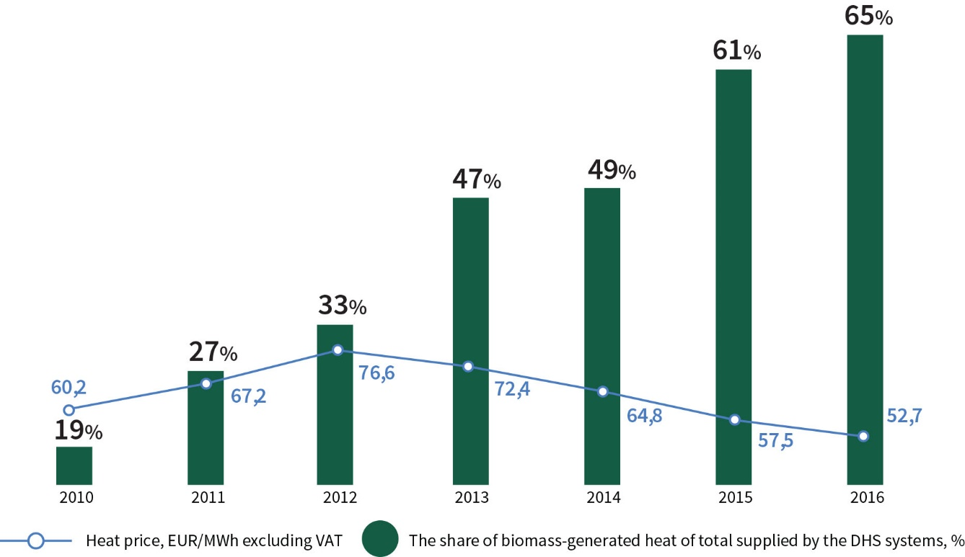
Source: Lithuanian District Heating Association, National Commission for Energy Control and Prices

- The main objective of the Strategy in the heating sector is the consistent and balanced renewal/optimisation of the DHS system, which ensures efficient heat consumption, reliable, economically attractive/competitive supply and production, enabling the deployment of modern and environmentally-friendly technologies using local and renewable energy sources, ensuring system flexibility and a favourable investment environment.
- The heat sector in Lithuania will be further developed in accordance with the following principles:
  - Transparency – ensure that heat supply activities are managed in an efficient, transparent and non-discriminatory way with respect to entities operating in the heat market and its consumers, including the acquisition of energy resources in the most transparent and competitive manner, ensuring the lowest costs to the final consumer;
  - Competitiveness – the rational use of investments necessary for the reliable supply of consumers with non-polluting heat at an acceptable price, ensuring the ability of DHS to compete with alternative heat supply methods;
  - Efficiency – the establishment of regulatory principles, which promotes the implementation of technical and management solutions in the systems of DHS enterprises, ensuring reliable and the most cost-effective heat supply to the end user;
  - Advancement – the adjustment of the system to the deployment of different environmentally-friendly and price-competitive innovative technologies in the areas of heat production, supply and consumption.
- In developing the heat sector in Lithuania, the following will be pursued:
  - District heat supply from renewable and local energy sources is 70% by 2020;
  - District heat supply from renewable and local energy sources is 90% by 2030;
  - District heat supply from renewable and local energy sources is 100% by 2050 and at least 90% of buildings in cities receive heating from the DHS.

Fig. 15. Meeting of the demand for DHS system capacity by fuel type
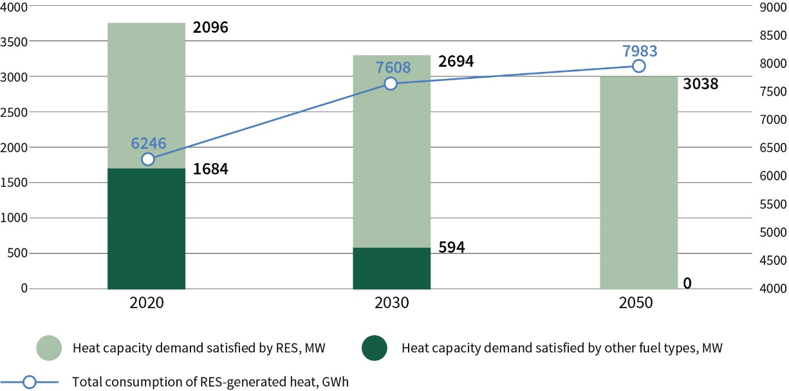
Source: Lithuanian Energy Institute

- The main directions for achieving the target in the area of the strategic heating and cooling sector :
  - Assessment and/or modification of the regulatory environment:
    - The establishment of a regulatory environment conducive to attracting investment and creating a non-discriminatory environment for all participants in the district heating market;
    - The promotion of heat, generated using DHS method, supply in buildings and prioritisation of urban areas in order to reduce air pollution;
    - The assessment of the current situation and future development of heat supply in the decentralised sector by setting out rational development directions and taking into account the changes in heat production technologies that increase the efficiency of heat production and consumption;
    - The assessment of the current situation and future development of the cooling sector and the establishment of guidelines for the most rational solutions to supply cooling;
    - The review of existing requirements for heat production reserve capacity.
  - Technical tasks for the implementation of the solutions:
    - The assessment of the feasibility of the use of solar energy technologies and heat storage facilities for the production of heat in a centralised manner, and, if economically feasible, their implementation;
    - The installation of a remote heat accounting data reading system;
    - The rational development of high-efficiency CHP plants that create possibilities for local electricity generation;
    - Timely updating (or replacement, if no longer economically and/or environmentally feasible) of:
      - Existing biofuel combustion plants in order to maintain the RES consumption;
      - Existing heat transfer facilities and their systems in order to minimise heat losses and to enable optimal development of the transfer network;
      - Heat units and/or heating and hot water systems of buildings, providing technical conditions, when economically reasonable, for individual adjustment of the heat demand for each consumer.

SECTION V

NATURAL GAS

- The share of natural gas in the country’s overall consumption of fuel and energy remains significant (25.1% in 2016), yet as of 2012, there has been a downward trend (35.9% in 2012). From 2006 to 2012, the country’s natural gas needs ranged around 33.5 TWh, while in 2013–2016, due to the increasing use of renewable resources, the overall consumption of natural gas decreased to 23.38 TWh. In 2016, 65% of natural gas imported in Lithuania was consumed in industry (the majority in the production of fertilisers), 21% in the energy sector, and 14% in households and the small business sector.
- Following the completion of the liquefied natural gas terminal in Klaipėda and the EU Third Energy Package in late 2014, and the second gas pipeline Klaipėda-Kuršėnai in 2015, the situation in the natural gas market has been substantially improved by enabling acquisition of natural gas in international markets, eliminating decades-old monopoly in the natural gas sector and creating competition. Lithuania has become able to independently supply itself with natural gas (and to supply significant quantities to the Baltic region) through the LNG terminal in the event of a disruption of supply from Russia or a lack of competitiveness. In 2016, 60% of the natural gas consumed in Lithuania was imported through the Klaipėda LNG terminal. These significant changes in the natural gas sector as well as favourable trends in international markets have led to a 50% decrease in the price of imported natural gas in Lithuania from 2012 to 2016, transforming Lithuania from one of the highest price for natural gas paying EU members to one of the lowest price natural gas paying EU members. Considering the results achieved, the global dynamics of the LNG market and the potential of the regional natural gas market, it is strategically important for Lithuania to secure long-term LNG supply in order to ensure a competitive and reliable supply of natural gas.

Fig. 16. Average import price of natural gas in 2007–2016, EUR/MWh
Source: National Commission for Energy Control and Prices.

- Lithuania, like the other Baltic states and Finland, still remains isolated from the EU’s common natural gas market. The Gas Interconnection Poland–Lithuania (GIPL) project will allow to integrate the Baltic states and Finland into the EU’s natural gas market and will contribute to the creation of the Energy Union, while enhancing the competitiveness and liquidity of the Lithuanian and regional natural gas markets, diversifying supply sources and routes, and creating opportunities to utilise the Klaipėda liquefied natural gas terminal not only for the needs of the Baltic states' consumers, but also Polish and Ukrainian consumers, thereby increasing security of supply in the region and, thanks to additional income from natural gas transmission and repeated gasification of liquefied natural gas, reducing the share of the liquefied natural gas terminal and natural gas infrastructure maintenance costs paid by the Lithuanian customers.

Fig. 17. Forecast of average natural gas prices to end consumers' in Lithuania, EUR/MWh
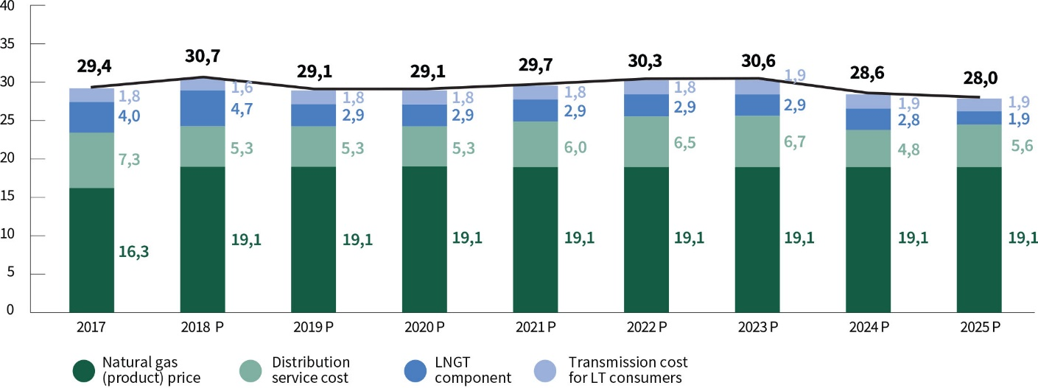
Source: The Ministry of Energy of the Republic of Lithuania.

- Significant changes in the natural gas sector relating to prevailing downward trends in natural gas consumption in the energy sector are driving up the costs of operation of the natural gas infrastructure and the costs of ensuring the security of natural gas supply for gas consumers and users of the system. Therefore, one of the main tasks in the field of natural gas is to reduce the cost of maintaining the natural gas supply infrastructure and to seek for lower natural gas import prices. The natural gas consumption level in industry, the transport sector and the households will depend on the competitiveness of natural gas as an energy resource. In the short to medium term, consumption of natural gas in the industry and in the transport sector is expected to partly absorb the declining natural gas consumption in energy production; meanwhile, the level of natural gas consumption in the long run will depend on its consumption for non-energy uses in the industrial and transport sectors.
- It is anticipated that in the energy sector in Lithuania, like in the EU, natural gas will remain an important energy resource for the transition to a low-carbon economy in 2050. In 2020–2030, the demand for natural gas in the country will reach 20.4–20.9 TWh, of which about 51% will be comprised of the demand for gas as a raw material in the fertiliser industry. The demand for natural gas is expected to increase to 24.5 TWh by 2040 and consumption of natural gas as a raw material for fertiliser production (non-energy use) is expected to amount to 44%. The increase of natural gas consumption as a primary energy resource in the country is associated with an increase in the RES balancing needs in the production of electricity and heat. In 2050, the total consumption of natural gas in the country will be 20 TWh, of which 55% will be consumed for non-energy purposes (fertiliser production).
- The main objective of the Strategy in the field of natural gas is to ensure a technically reliable and diversified supply of natural gas to consumers based on efficiency and cost-effectiveness principles and competitive prices.
- The objective of the natural gas sector will continue to be pursued based on the following principles:
  - Efficiency – Lithuania needs to make more effective use of its geographical location and well-developed natural gas supply infrastructure, to actively participate in the search of new natural gas transit routes and infrastructure users, including the attraction of new industrial users to Lithuania who are intensively using natural gas in the production process; this way, Lithuania will more effectively use the existing natural gas infrastructure, while the income will reduce the infrastructure maintenance costs to all natural gas consumers in Lithuania;
  - Competitiveness – in order to increase the competitiveness of natural gas as an energy source and to ensure the continuity of their activities, natural gas suppliers and natural gas infrastructure operators must ensure the supply of natural gas to Lithuanian consumers at economical costs that are based on the cost-effectiveness principle and prices that are competitive to those of alternative energy; it should be achieved by improving access to infrastructure, optimising the costs of maintaining natural gas infrastructure, and implementing a coherent and ambitious programme for boosting the efficiency of infrastructure operators;
  - Innovation – the promotion of cooperation between energy, science and study institutions and business organisations will lead to the development of innovative technologies for the use of LNG in the energy, transport, shipping and industry sectors in Lithuania. By fully utilising its LNG infrastructure and scientific potential, Lithuania must become a leader in LNG technologies, distribution and excellence in the Baltic region; innovation is related to the deployment of smart energy networks and smart energy accounting systems and the application of power-to-gas technologies;
  - Integration – in order to make better use of the existing infrastructure, increase liquidity of natural gas markets and competition among suppliers, the Baltic natural gas markets must be fully integrated into the common regional natural gas market by creating favourable conditions for natural gas trade within the region and the functioning of the regional market within the integrated European natural gas network;
  - Security – guaranteed secure, reliable, diversified supply of natural gas to satisfy the needs of the customers of the country by ensuring Lithuania’s ability to independently supply itself with natural gas from international LNG and EU natural gas markets.
- In pursuit of the strategic natural gas objective, the aim will be to:
  - by 2020:
    - create a regional Baltic natural gas market (with the possibility to expand to Finland) in pursuit of better liquidity of the natural gas market, competitiveness and more efficient use of the existing infrastructure in Lithuania for natural gas transit and export to the region;
    - reduce the operating cost of LNG and natural gas transmission and distribution infrastructure;
    - develop and exploit the potential of being the centre for LNG technology, distribution, storage and excellence;
    - modernise the natural gas transmission and distribution infrastructure;
  - by 2030:
    - make effective use of the well-developed natural gas supply infrastructure as well as opportunities provided by access to international LNG markets and integration in the European natural gas market;
    - ensure that the natural gas system, as an integral part of the common energy system, ensures the reliable and competitive fulfilment of RES needs, electricity reserve capacity and balancing needs, efficient cogeneration as well as industrial and household needs.
  - In 2050, when Lithuania switches to energy production from non-polluting (low GHG and air pollutant emissions) energy sources, Lithuania should ensure that this transition period does not lead to negative economic consequences for the state, the natural gas industry and households, in accordance with the principles of sustainable development.
- The main directions and tasks for achieving the target:
  - To create a regional natural gas market;
  - To decide on the long-term LNG imports to Lithuania;
  - To implement the Gas Interconnection Poland–Lithuania (GIPL) project;
  - The development and maintenance of the natural gas network and infrastructure is oriented towards the security and competitiveness of the system, reduction of network maintenance costs and more efficient use of existing infrastructure;
  - To fully develop capacities of the LNG Cluster and LNG Excellence Centre in Lithuania;
  - In line with the principles of sustainable development, to ensure transition to energy production from non-polluting sources without any negative consequences to industries, businesses and households using natural gas.

SECTION VI

FUELS

- Petroleum products account for a large share (38.9%) of the country’s primary energy consumption.
In 2016, the total consumption of petroleum products accounted for 1.7 million tons per year in road transport, of which 80.8% was diesel for road transport, 12.5% – petrol and 6.6% – liquefied petroleum gas. In recent years, the popularity of diesel has grown as 8.2% more was consumed in 2016 than in 2015. Petrol demand increased by 5%, while liquefied gas dropped by 5.7%. In 2016, biofuel consumption in road and rail transport was 4%.

Fig. 18. Consumption of petrol, diesel and fuel oil, thousand t
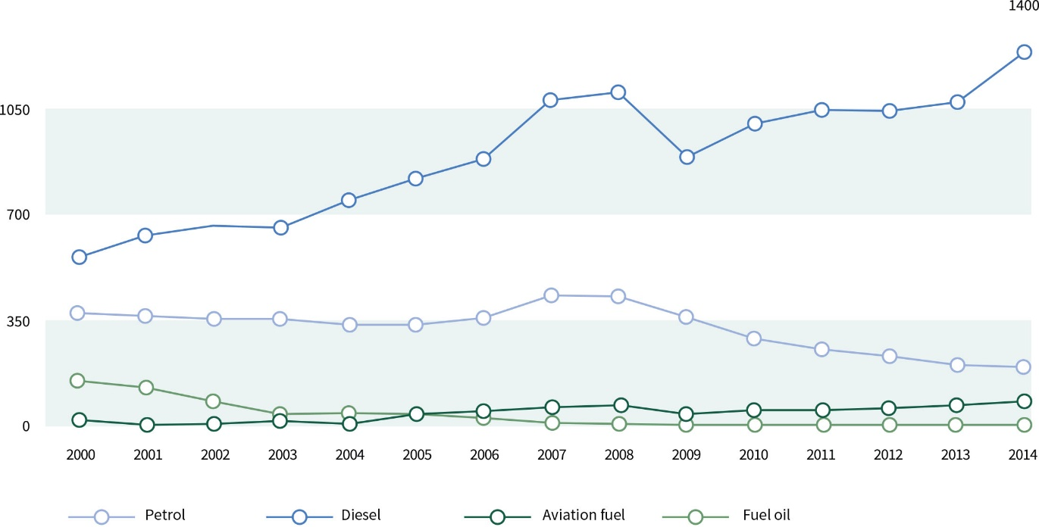
Source: The Ministry of Energy of the Republic of Lithuania.

- Lithuania has the only oil refinery in the Baltic region with an annual capacity of 10–11 million t, a terminal in Būtingė for oil import and export via the Baltic Sea with capacities at 6.1 and 8 million t/year respectively, and one of the most modern reverse terminals for petroleum products in the region in Klaipėda with an annual capacity of 7.1 million t. At present, Lithuania has sufficient technical capabilities to import oil and petroleum products from various countries, has diversified supply of petroleum products and is technically protected from possible supply disruptions from any one country. Petroleum product stocks for the needs of Lithuanian consumers have been accumulated and are continuously maintained, corresponding to 90 days’ worth of net petroleum product imports. The future development of the Lithuanian oil and petroleum product supply system will be influenced by the transport system trends, global changes and – in response to them – the legal framework adopted by the EU member states. Climate-related policies, fluctuations in the prices of oil and petroleum products, and the concentration of oil resources in unstable regions of the world will lead to the search of alternatives to these traditional resources in the transport sector.
- Due to improved economic conditions, final consumption of energy in the transport sector is increasing every year, while the share of biofuels is decreasing. Lithuania has a first-generation biofuel industry and therefore aims to maximise local consumption of sustainable local biofuels and contribute to strategic objectives. Gradually, the role of alternative fuels (electricity, hydrogen, biofuels, LNG, compressed natural gas, etc.) will increase in transport sector and the share of RES will continue increasing.
- The main objective of the Strategy in fuels sector is to gradually shift to less polluting fuels and electricity consumption by making flexible and efficient use of the existing infrastructure in the oil and petroleum product sector and the local RES potential.
- Fuels sector development in Lithuania should continue in accordance with the following principles:
  - Competitiveness – ensuring diversified petroleum products supply and their supply alternatives as well as effective competition among market participants;
  - Security – maintenance of state stocks of oil and petroleum products as well as oil refining capacities;
  - Integrity (transformation) – integration of alternative fuels, reducing dependence on imported fossil fuels, increasing energy efficiency, reducing pollution.
- In pursuit of the strategic objective of the fuels sector Lithuania will aim for the following targets:
  - By 2020, 10% of energy consumption in the transport sector is from RES;
  - By 2030, 15% of energy consumption in the transport sector is from RES and there is 50% less use of cars running on traditional fuel (petroleum and diesel) in cities;
  - By 2050, 50% of energy consumption in the transport sector is from RES and there is 100% less use of cars running on traditional fuel (petroleum and diesel) in cities.
- The main directions for achieving the targets:
  - To increase the share of biofuels consumed in the transport sector in the general fuel balance and, given the national nuances, increase the share of biofuels mixed in fossil fuels up to the permissible limits set by the EU standards;
  - To promote the use of electric vehicles, including electric cars, in the transport sector, while preserving and developing the existing network of electric vehicles; to create an electric vehicle charging network, to increase the electrification of rail transport;
  - To renew public transport fleets consistently replacing them with vehicles running on electricity or alternative fuels;
  - To promote the use of natural gas and other alternative fuels in heavy transport, maritime transport and public transport, exploiting the existing potential of the LNG distribution station and other LNG infrastructure.

CHAPTER VI

RESEARCH AND DEVELOPMENT DEMAND AND DEVELOPMENT OF COUNTRY’S BUSINESSES

- As a result of completed significant strategic energy projects, the successful design and development of individual energy branches, Lithuanian energy companies, business enterprises and science and study institutions have accumulated exclusive competences in the field of solar energy, biomass, geothermal energy, LNG and other areas, which need to be maintained, further developed and strengthened. It is necessary to achieve that research and development in Lithuania and the resulting products acquire industrial production and become part of Lithuanian exports, thus contributing to the country’s economic growth. This requires focusing on priority research directions and, at the same time, ensuring the practical use of the results of these studies and of existing and advanced competences.
- Taking into account the specifics and needs of the Lithuanian energy sector, the strategic goals, the existing and desired competences, the following priority directions for research and development in energy have been identified:
  - The planning of the future development of the energy sector, energy economics;
  - The modernisation of existing energy production technologies based on new challenges and requirements;
  - The development of new energy production and storage technologies with low GHG and air pollutant emissions and resilience to climate change and their integration into the network;
  - Technologies using local energy generation and renewable energy sources;
  - The analysis of the operation of the electricity system and improvement of its control;
  - Technologies relating to distributed generation, smart networks, production and use of new promising energy types;
  - Ensuring reliability and high-quality of electricity supply, vulnerability of electricity systems and optimisation of operating modes;
  - The functioning of electricity markets, power mechanisms and the proactive involvement of consumers in the operation of the electricity system and markets;
  - Energy and cyber security, reliability of energy equipment and systems, resilience to cyber-attacks;
- In order to achieve the use of energy expertise and the results of research and development in other areas of the economy as well as increased export and opening of new businesses in the country, the following will be undertaken:
  - Increasing synergies among science and study institutions, energy companies and engineering companies by promoting various forms of cooperation through the use of investments from the EU research and innovation programme Horizon 2020, national and other programmes, developing digital energy innovations and improving technologies in Lithuanian energy sector, thus strengthening the ecosystem of scientific research and innovation in Lithuania;
  - In order to achieve closer cooperation between energy companies and educational institutions, partnership-support programmes for energy companies and engineering companies shall be drawn up to encourage cooperation by developing and deploying digital energy innovations and improving technologies;
  - Using fiscal measures to stimulate investments in the technological development of solar, wind, biomass, biofuel and other renewable energy sources, improvement of production, acquisition of technology and development of a centre of excellence as well as development of LNG technologies and expansion of the centre of excellence;
  - Engagement of engineering companies in the development of new LNG technologies, technological equipment and transport measures and integration of such companies in the market;
  - Encouraging the development of new energy production technologies, including RES, distributed energy generation and smart grids, and their integration into the network;
  - Promotion of the production of electricity storage technologies, attracting investments in the production of these technologies in Lithuania;
  - Assessment of opportunities for the production of offshore wind energy technologies, attracting investments for the production of these technologies in Klaipeda Port;
  - Development, production and export of technologies for the production and use of local energy resources;
  - Promotion of IT solutions for optimising the energy sector and their testing in Lithuania, support for the export of such products;
  - Strengthening of companies constructing energy facilities and infrastructure in order to increase the added value they create, stimulate the export of services and the innovation of these enterprises;
  - Promotion of the production of solar energy technology entrenching the status of Lithuania as the largest excellence centre and exporter of solar technology in the Baltic and Nordic region.

CHAPTER VII

STATE-OWNED ENTERPRISES AND ENERGY SECTOR MANAGEMENT

- The energy sector represents a significant part of the Lithuanian economy, and some state-owned energy enterprises and facilities have a strategic significance for the national security of Lithuania, ensuring reliable energy supply and opportunities for the development of an efficient energy market. In order to ensure the achievement of this objective, state control in these strategic energy enterprises will be maintained, while allowing reliable private capital in order to enhance the transparency and efficiency of such enterprises and to attract private capital to participate in strategic energy projects.
- The security of the state energy sector will be ensured observing the following principles:
  - Physical and cyber-security of energy infrastructure based on risk assessment;
  - Ensuring the compliance of investments in the energy sector with national security criteria;
  - Protection of the activities and personnel within the energy sector.
- To improve the resilience of the information infrastructure managed by the energy sector companies to cyber-attacks an approach based on risk assessment will be established where the used cyber security measures are proportional to curb the identified risk, correspond to the importance of information and the risk posed to it. Special attention will be given to the planning of assurance of continuity of the operation of information infrastructure of the energy sector, to regulation, to practical testing of cyber incidents and activity continuity plans during training and exercises.
- In order to ensure the highest level of transparency in the management and operation of the energy sector companies, their efficiency and professionalism, special attention should be paid to the following key management principles:
  - Resistance to corruption;
  - Transparency of operations;
  - Professionalism, knowledge development and preparation of necessary specialists, capacity building of employees and managers in energy technology, cyber security and energy economics;
  - Effective management and implementation of innovative technologies;
  - Active engagement of the public by observing the operation of state and municipality managed and controlled companies which provide public services, by putting forward suggestions with regard to more transparent and more efficient activities of such companies, the lowest energy generation and transmission costs, and the lowest energy prices to consumers.
- The management of state-owned energy enterprises must be ensured through the establishment of corporate governance principles, operational objectives, management organisation models, management structures and accountability, operational monitoring and control systems for these enterprises, i.e. by:
  - clarifying the activities of the energy enterprises and formulating clear shareholder requirements for the enterprises;
  - introducing corporate governance based on best global practices, ensuring the transparency of business activities of the enterprises;
  - forming effective management for the enterprises, increasing the number of independent members, hiring international experts if necessary;
  - ensuring the necessary competences, attracting and retaining highest level professionals, as business success is determined by people;
  - strengthening corruption prevention through control and accountability;
  - aiming at a stable regulatory environment that meets EU requirements and best international practices to govern energy activities.

CHAPTER VIII

IMPLEMENTATION OF THE STRATEGY

- The implementation of the Strategy shall be coordinated by the Ministry of Energy. The implementation of the Strategy involves the Ministry of Energy, other state and municipal institutions, bodies, enterprises, organisations and other persons specified in the Strategy Action Plan and/or programmes.
- To implement the provisions of the Strategy, the Government or its authorised institution shall approve the Strategy Action Plan and other strategic planning documents related to the Strategy, which shall include measures for the implementation of the Strategy provisions.
- The Government shall annually report to the Seimas (the National Parliament) on the implementation of the provisions of the Strategy.
- The Ministry of Energy is supported in coordination of the Strategy’s implementation by a state-owned entity, which analyses the trends in the energy sector and submits proposals to the Ministry of Energy to ensure timely implementation, improvement and updating of the Strategy.

Speaker of the Seimas Viktoras Pranckietis

GTC—gas turbine CHP plant; CCGT—combined cycle gas turbine power plant, CCGT CHP—combined cycle gas turbine CHP plant, SE—steam-electric power plant, SCC—steam cycle CHP plant, Mini CHP—mini CHP plant, ICE CHP—a CHP plant with an internal combustion engine, WHB—water heating boilers, SC—solar collectors, End users: transport, industry, decentralised consumers.
EU legislation is used to create an EU internal energy market and strengthen its effective operation and resilience, regulatory and financial instruments are used to increase the degree of interconnectivity of Member States’ energy infrastructures, strengthen the EU’s external dimension of energy policy, encourage the development of renewable energy and increased energy efficiency.
Communication from the Commission to the European Parliament and the Council “A European Strategy for Energy Security”, COM/2014/330 final. http://eur-lex.europa.eu/legal-content/EN/ALL/?uri=CELEX:52014DC0330&qid=1407855611566
In 2012, compared to 1990, EU GHG emissions were reduced by 8% (2020 target—20%). In 2015, a 16.7% RES share in the EU’s final energy consumption was reached (2020 target—20%) EU’s energy efficiency target for 2020 (20%) was already achieved back in 2016.
Estimates by Lithuanian Energy Institute and Epso-g.
European Commission Communication on a policy framework for climate and energy in the period from 2020 to 2030 (COM (2014) 0015). http://eur-lex.europa.eu/legal-content/EN/TXT/?uri=COM%3A2014%3A15%3AFIN
Provisions of the European Commission’s 2014-2020 Guidelines on State aid for environmental protection and energy (2014/C 200/01).
The Republic of Lithuania Law on Recognition of the Nuclear Power Plant under Construction in the Ostrovets District in the Republic of Belarus as Unsafe and Posing a Threat to the National Security of the Republic of Lithuania, its Environment and Public Health.
Lithuanian Energy Institute.

